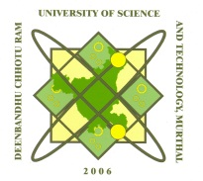**COMPUTER SCIENCE AND ENGINEERING DEPARTMENT**

**Deenbandhu Chhotu Ram University of Science and Technology**

**Murthal– 131039, Sonepat, Haryana**

DCRUST/CSE/ Dated: 31.07.2025

**NOTICE**

**BCA Admissions – 2025**

**Final Status of Vacant Seats in BCA Programme**

This is to inform all concerned that **all seats in the BCA programme have been filled**. **No seat is available** for admission under any category.

This notice is issued for the information of all interested candidates.

**CHAIRMAN, CSE**